First Page

Lead Central – Call Tracking for Quickbooks

Home page (www.theleadcentral.com)

You tube video
Slogan: Call Tracking for Quickbooks!
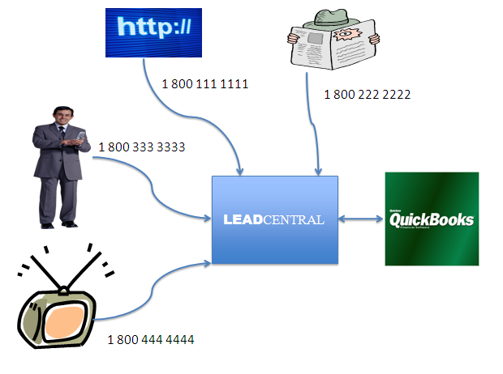
You tube video that we will record tomorrow in the middle of the page

You need lead central if you want to have the following answers
- Are My Ads Working
- Do I maximize my ad budget?
- How do I motivate business partners to send me leads?
- What are my leads costing me

Steps to use lead central
- Create lead source
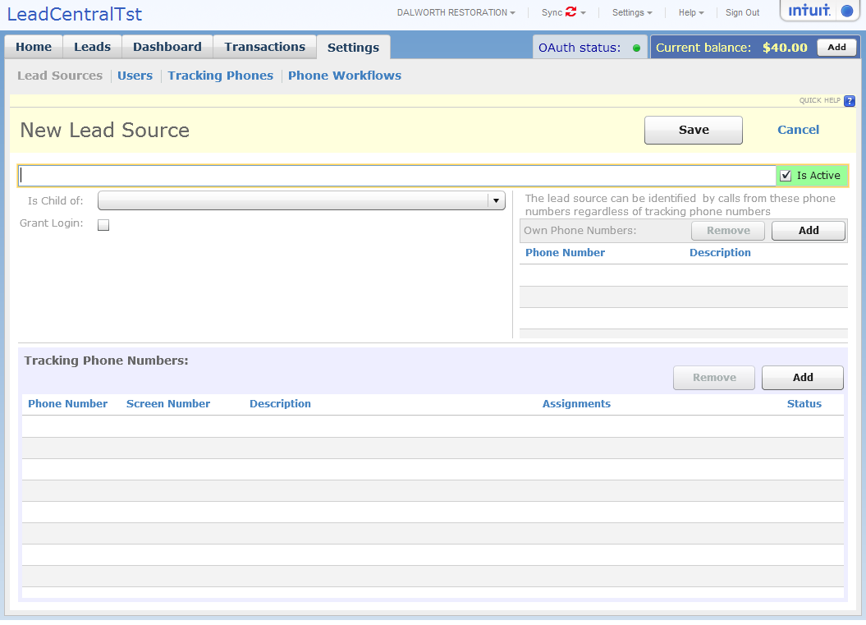
- Purchase tracking phone number
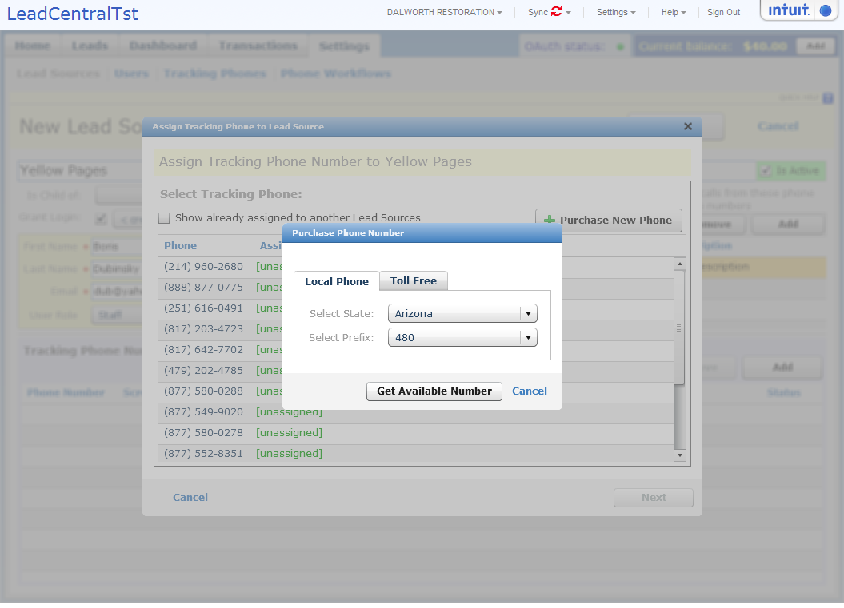
- You and your business partner can listen to the leads generated and revenue produced. (Modify this screen shot with 20 leads from different phone numbers and names like Smith Jackson, Cathy Smith, Monty’s Plumbing, …. Make sure from phone are filled) Make sure they can see player
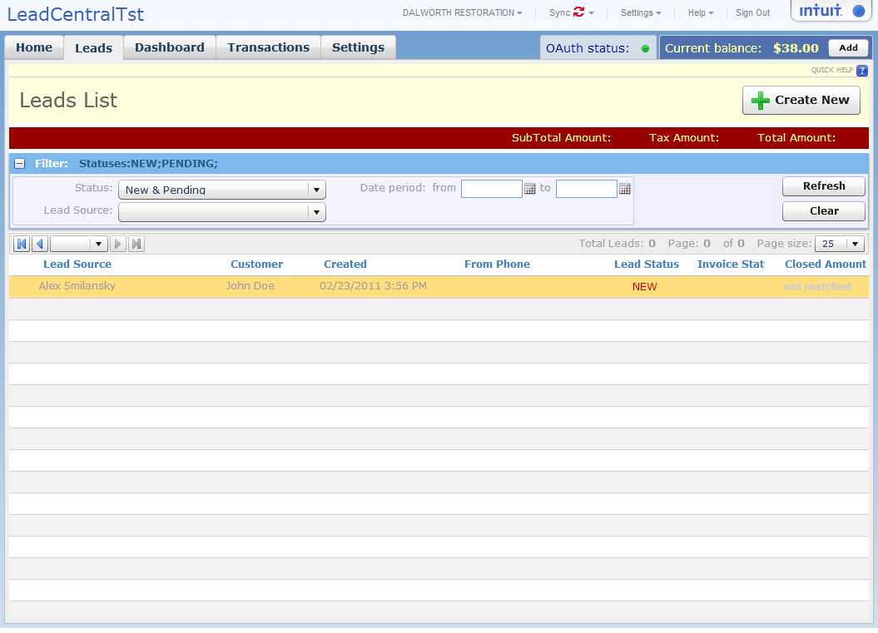
- Match leads to Quickbooks invoices
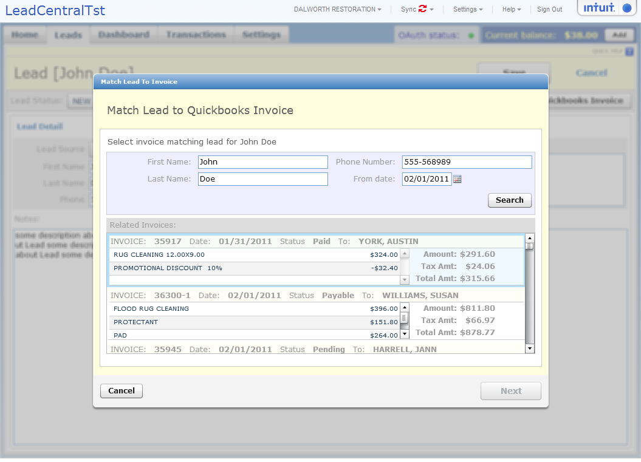
- You and business partner can track revenue generated from each phone number
- Review information for each Business Partner (Need to show 30 business partners with lost of leads and revenue on this screen for different dates
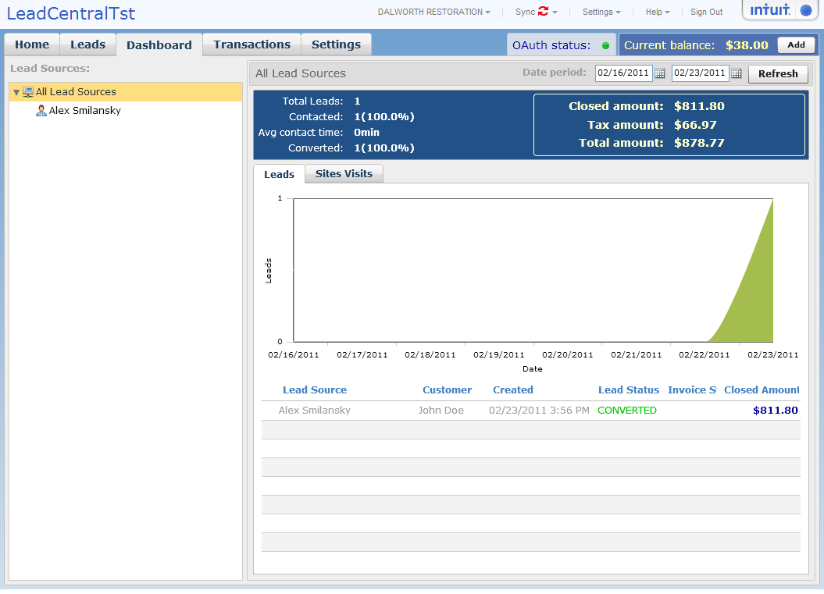

Help Page (www.theleadcentral.com/help)

First Time Setup
www.theleadcentral.com/help/setup

Youtube video on setup.

You will see this screen when you first sign up. Please follow the steps required –
Authorize Lead Central to Read Quickbooks Data.
(Lead Central needs to read quickbooks invoice data to enable matching leads to invoices. Lead Central does not modify your Quickbooks data. )
1.2 Setup Phone workflows
Specify rules how to handle phone calls depending on time of the day
1.3 Setup Lead Sources
Modify phone to my phone (214) 335 4143
Support Email – support@theleadcentral.com
Remove technical info:
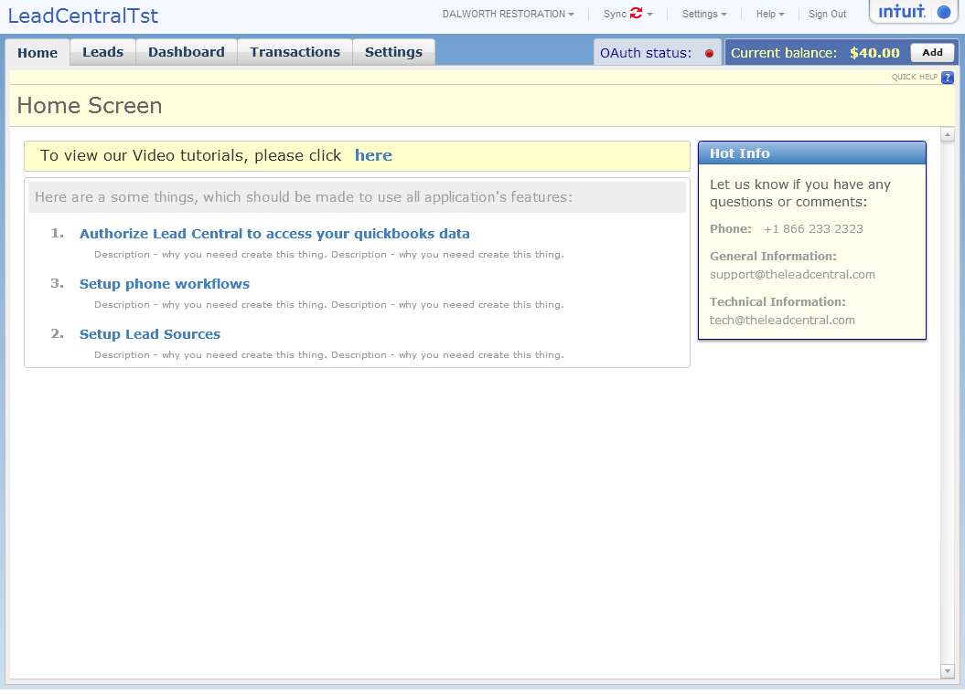
Authorize Lead Central to access Quickbooks Data
Lead Central requires Read Only access to Quickbooks data to enable matching leads to Quickbooks invoices
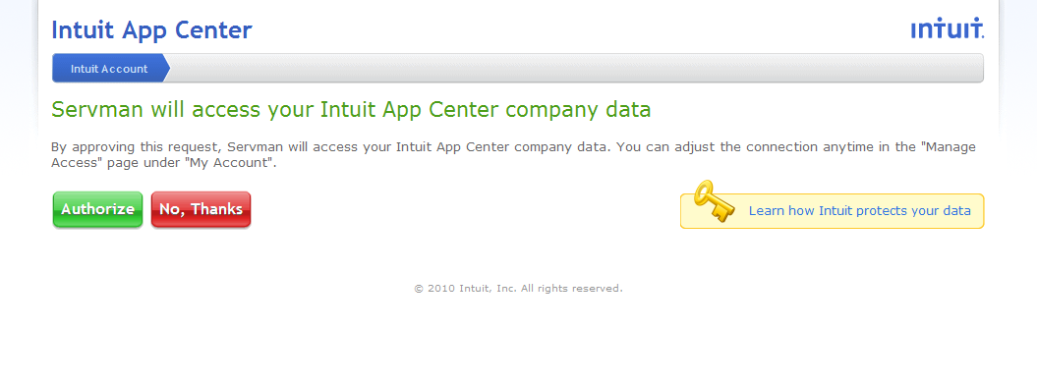
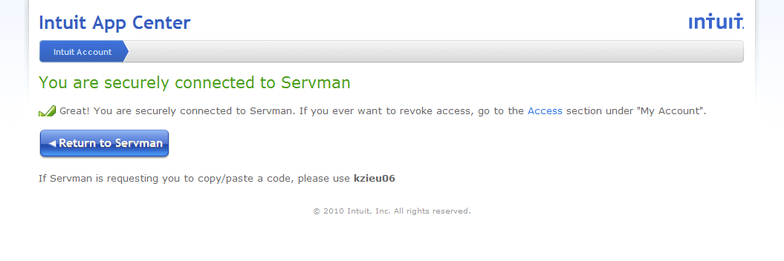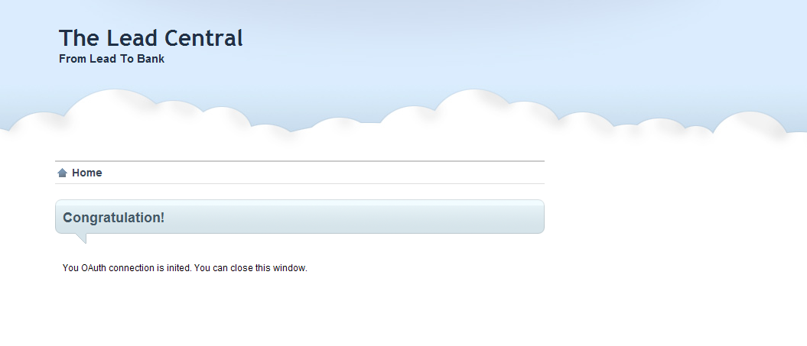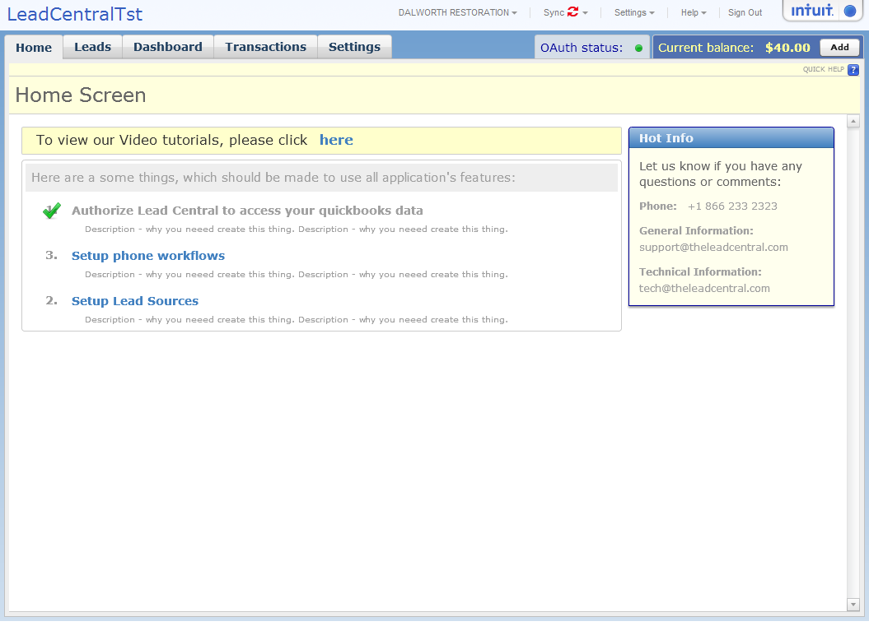

Specify phone work flows

Setup phone workflows – Specify message system will play as welcome message if phone is busy and phone numbers to redirect calls from

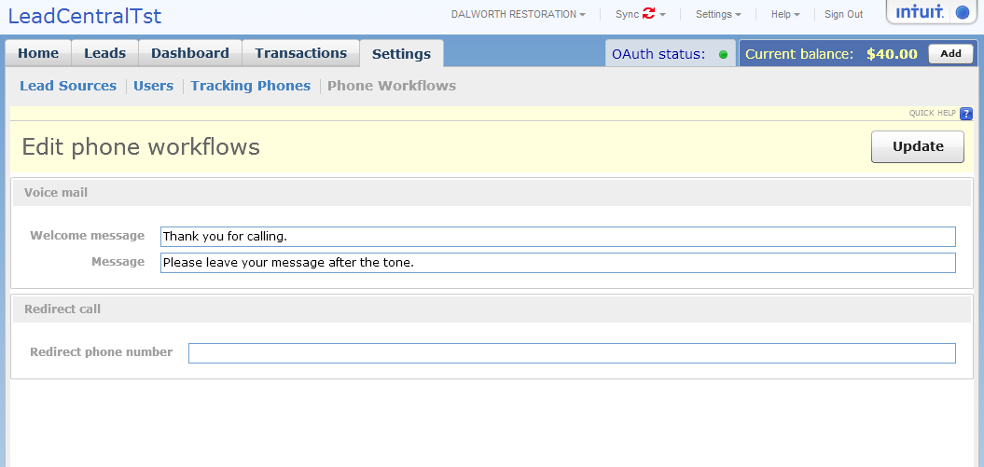
Specify lead sources
Lead sources represent either a business partner or ad campaign
Please click here to see how to manage lead sources
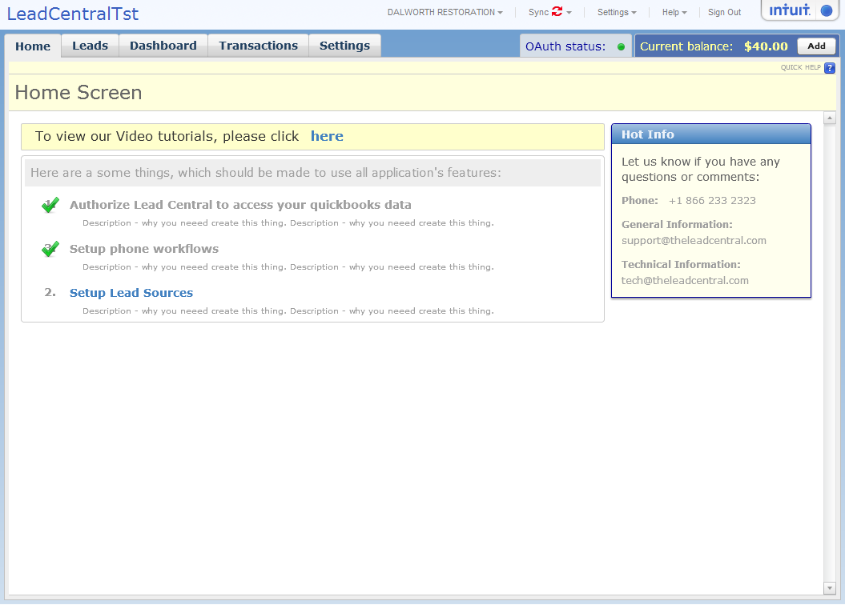

You are done. You business partners will receive emails to sign up and they can start sending you leads!
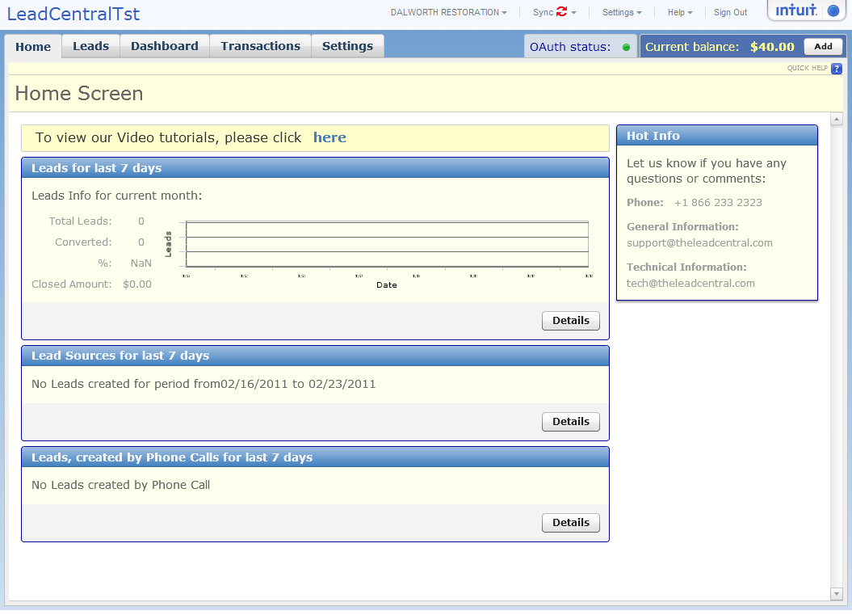

FAQ (www.theleadcentral.com/help/faq)
Just list of FAQ

Pricing (www.theleadcentral/pricing)
Lead central is billed by Intuit Partner Platform.
Will describe it here in more details.

Tour www.theleadcentral.com/help/users)

Users

Lead Central Support the following Users –

- Administrator
Administrator can use all the functionality of Lead Central
- Company Staff,
Company Staff doesn’t have access to setting menu
- Business Partner.
Business partner does not have access to setting menu and can view only lead associated with her.

 | Administrator | Staff | Business Partner
Settings | Yes | Only her own settings | Only her own settings
View Leads | ALL | ALL | Only leads generated her lead sources
Create New Lead Source | YES | YES | NO
Can View Call Transactions | YES | NO | NO
Dashboard | Can see all leads | Can see only lead sources associated with her | Only Leads generated with her

Administrator Functionality (www.theleadcentral.com/help/users/admin)
Company Owners can manage lead sources, buy phone numbers, Manage Leads

Home Page
www.theleadcentral.com/help/users/admin/home
Screen Shot of the home page
Youtube video

Manage Leads www.theleadcentral.com/help/users/admin/leads
This screen show you 10-15 leads already with American names. One of the leads is selected and player is shown

Leads are created automatically when phone calls are received.

Leads can be listened from this screen.

Edit Lead :
No Joe Doe. Should be James Smith or Brenda Smith. Text can be “My water header leaked. Please call us as soon as possible”
Player must be shown on this screen shot.

You can change status of the lead, listen to this lead, write notes or match this lead to quickbooks invoices.
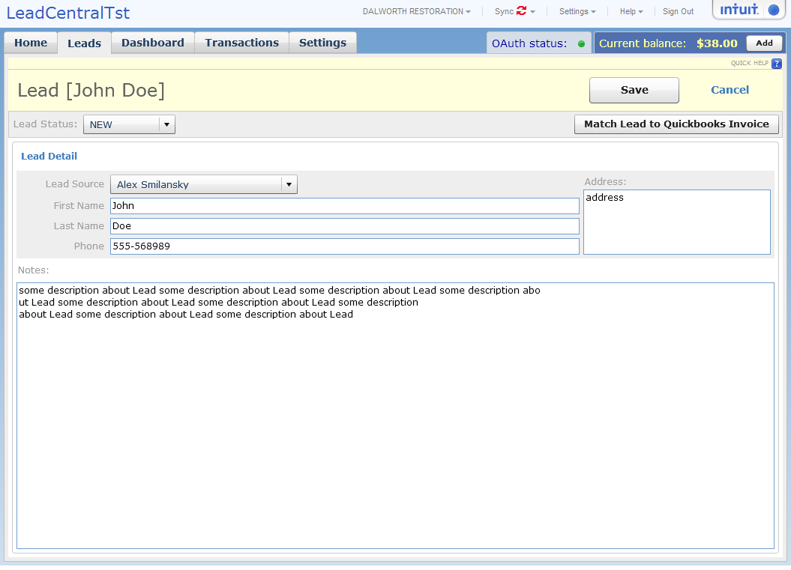

Match Lead To QuickBooks Invoice:

Lead central will try to predict which invoice this lead should be matched to. You can search invoices and connect them to leads..

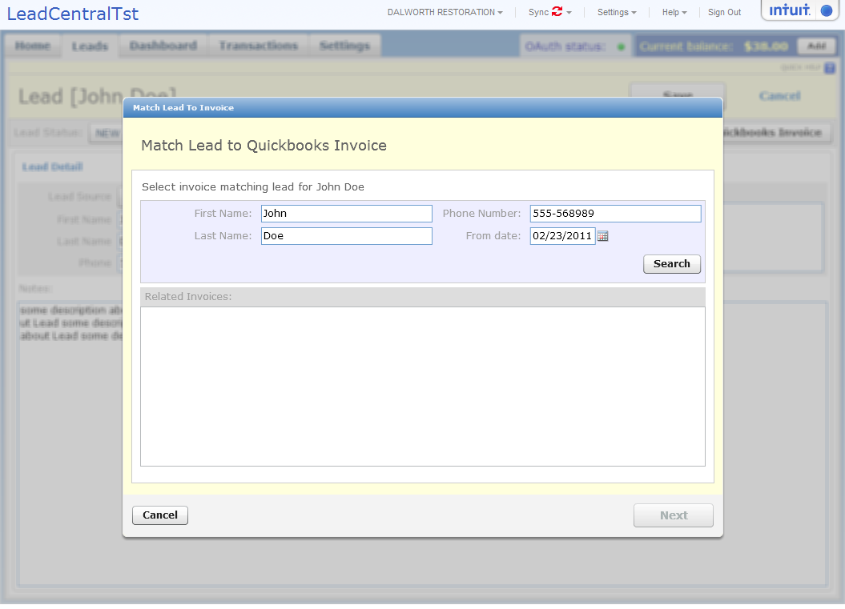

Select QuickBooks Invoice:

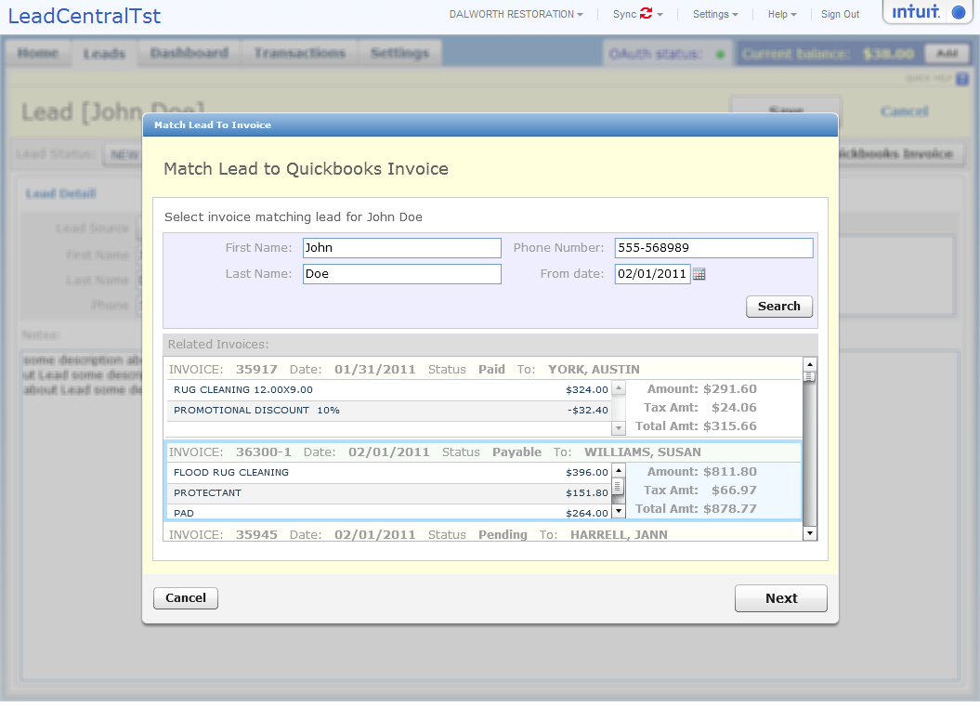

Review matching:
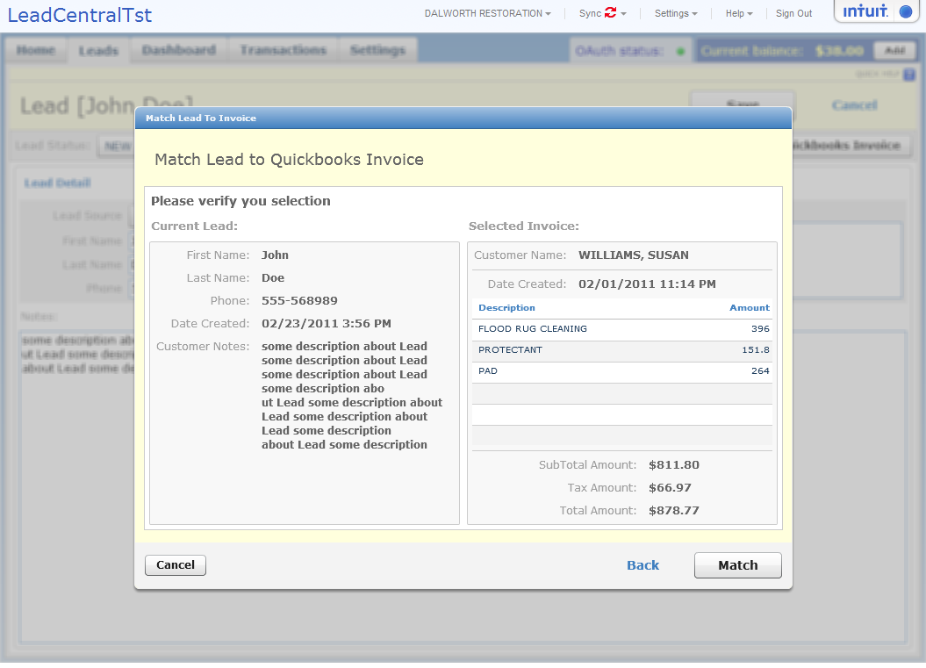
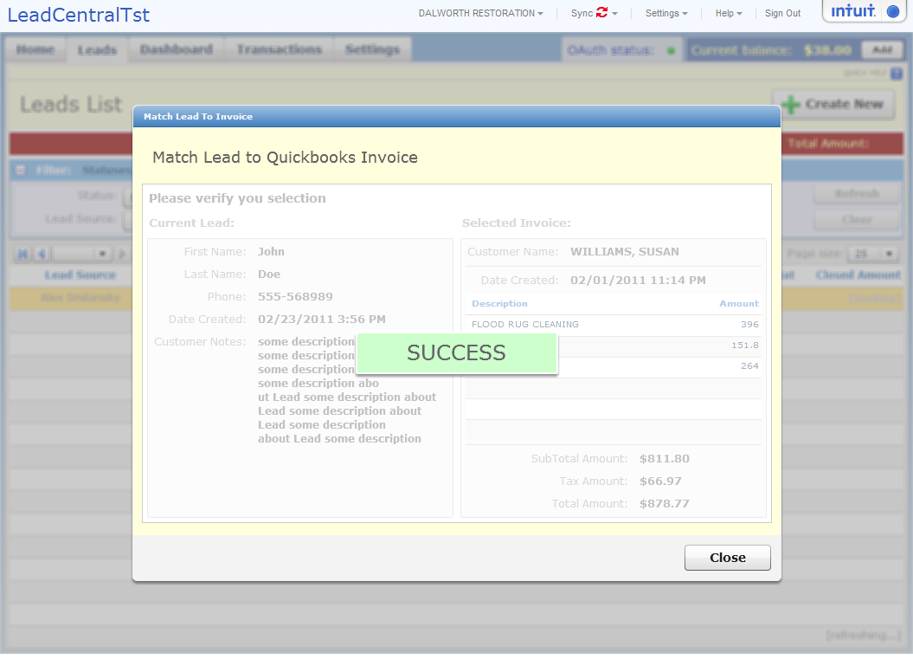

Lead is Connected to Quickbooks invoice.
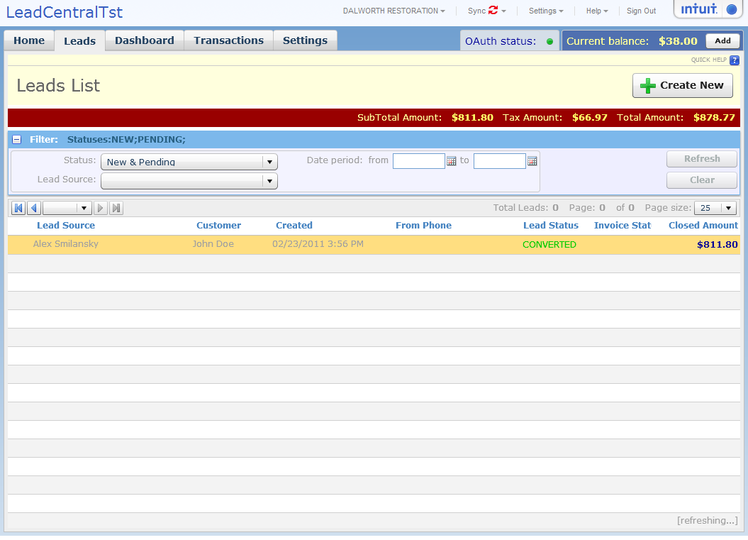

Dashboard www.theleadcentral.com/help/users/admin/dashboard
You tube video
Dashboard: Leads by Lead Source and date period:

Phone roations on web sites:
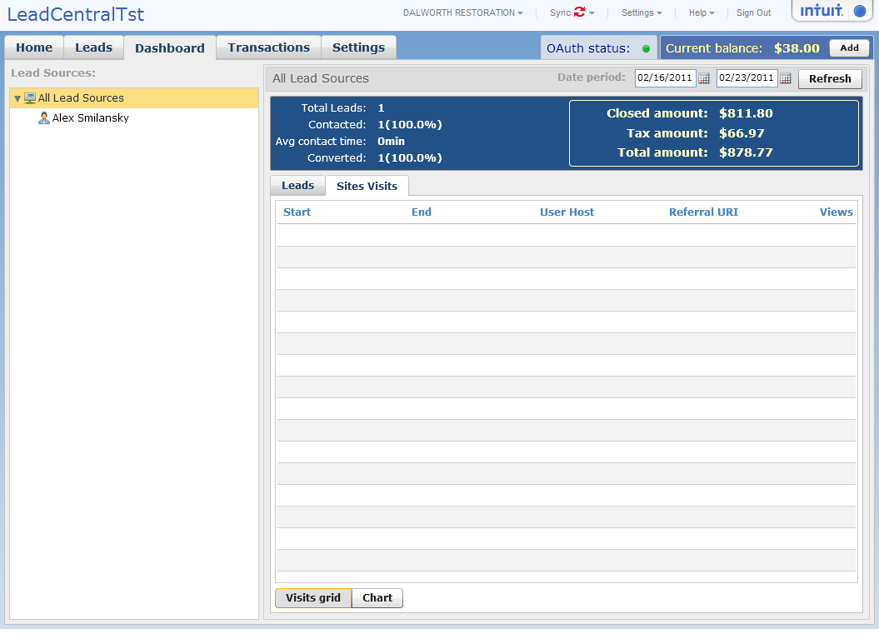

Review transaction balance
ww.theleadcentral.com/help/users/admin/balancereview

You Tube video

Administrator can review transaction balance to see how the money where spent on each call. Administrator will receive email notification if balance will be low so she can pay extra to avoid service suspension
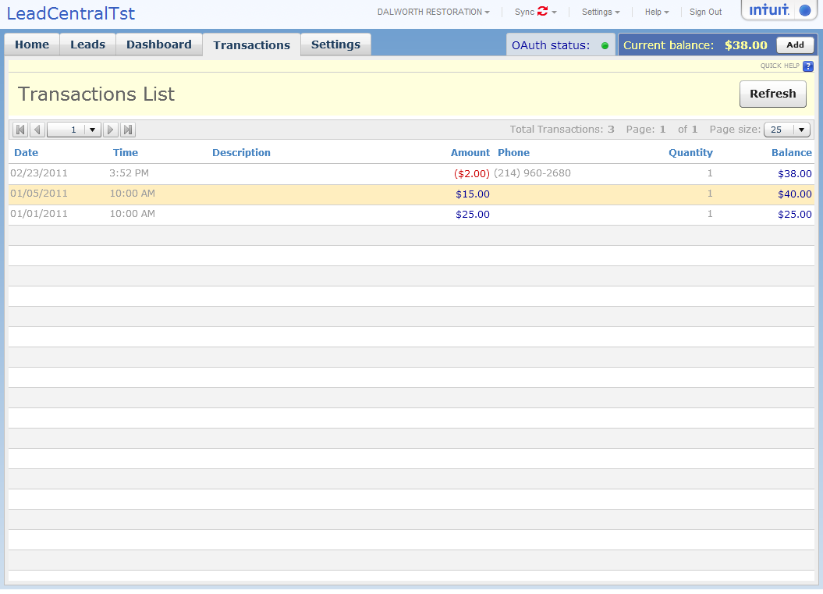

Add Extra payment to avoid suspension of calls
Payment is processed via secure Intuit Merchant Service

You Tube Video
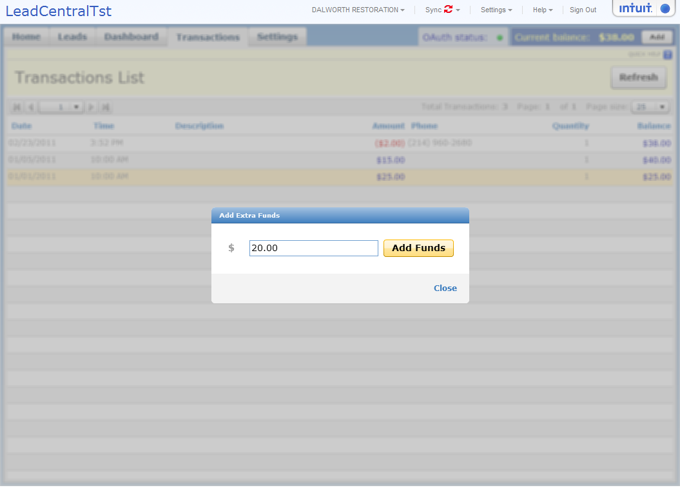
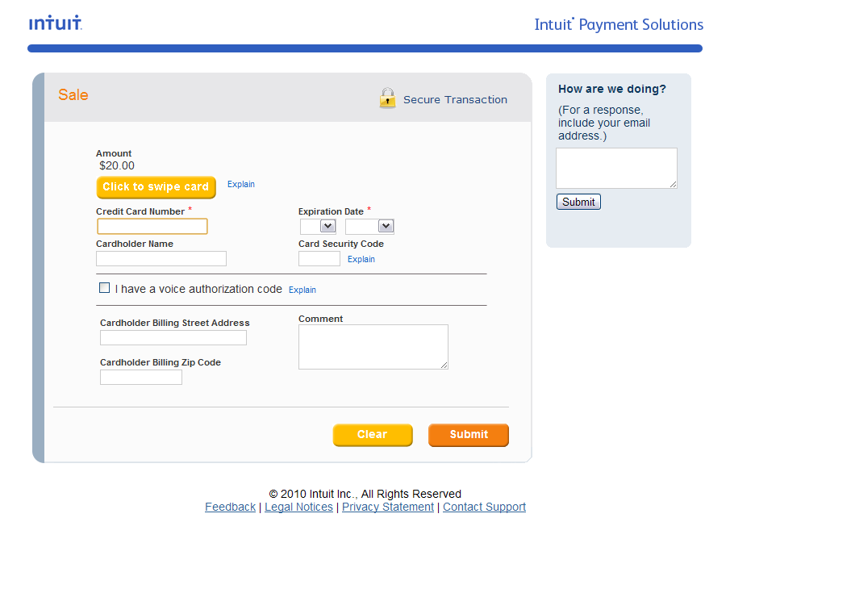

Fill all fields and make payment:
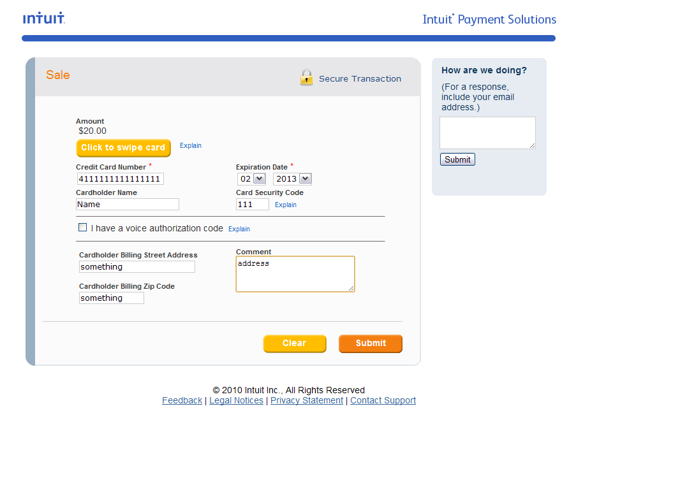
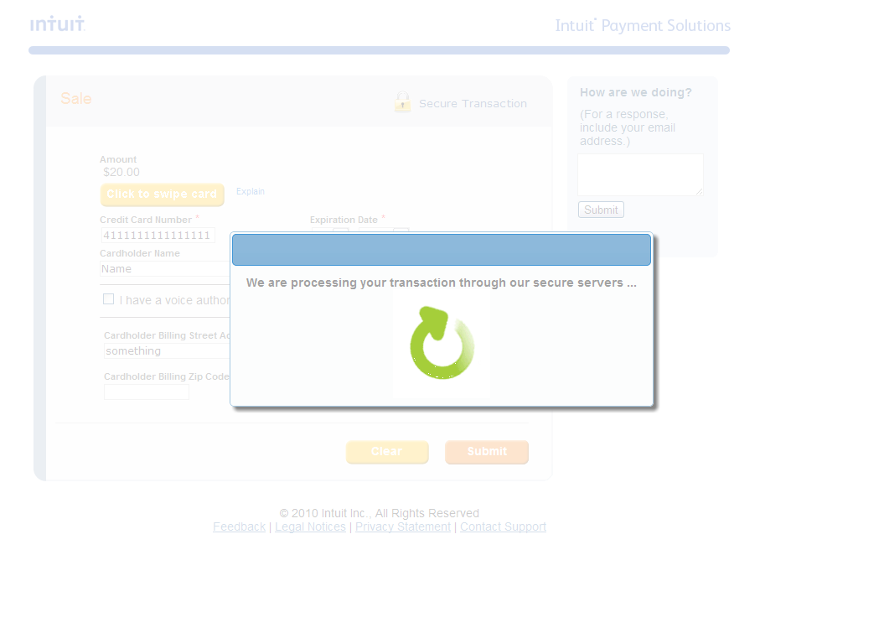

Return to Lead Central:
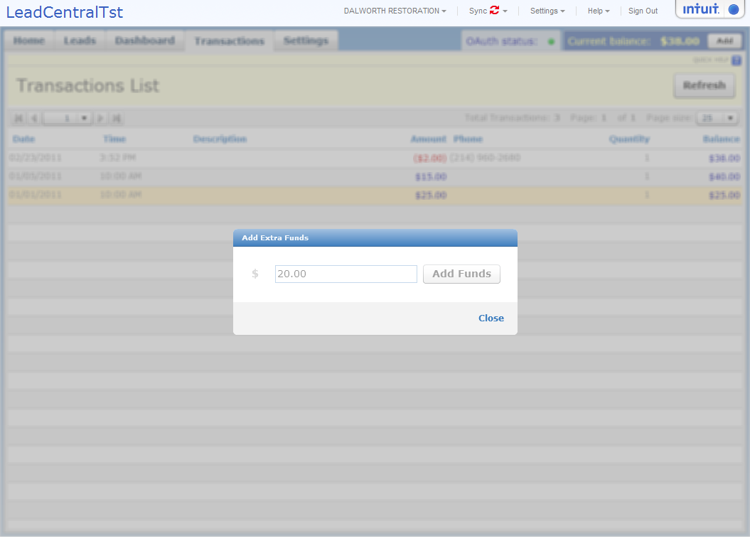
Email is sent to notify Administrator that payment is received

Settings

Manage Lead Sources www.theleadcentral.com/help/users/admin/settings/leadsources

Create new Lead Source
Short video here how to create new lead source

Q: What is a “Lead Source”?.
A: Lead Source represent any source of leads. It can represent a business partner that will login to lead central or marketing camping that would not be associated with Lead Central user.

Click on Create New
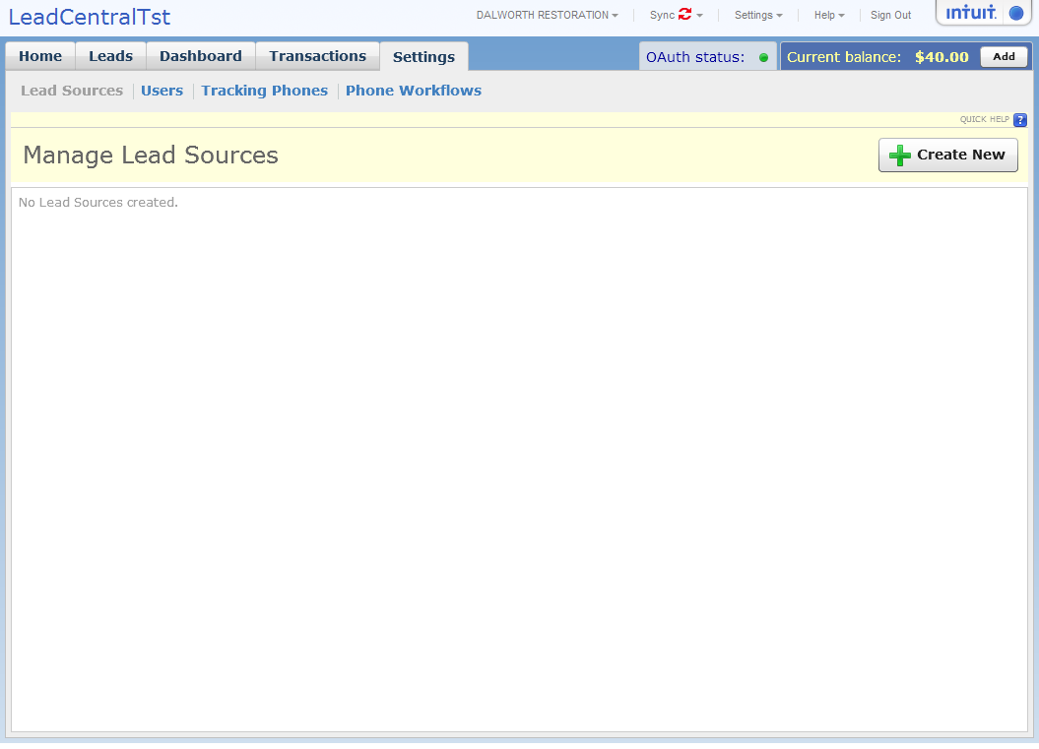

Enter name of the lead source (can be company, person, adword camping, flyer, etc)

If a lead source

(this is bad example. If you put Yellow Pages, then it should now have login. Change this screen shot to “Best Maid Services”). Put American
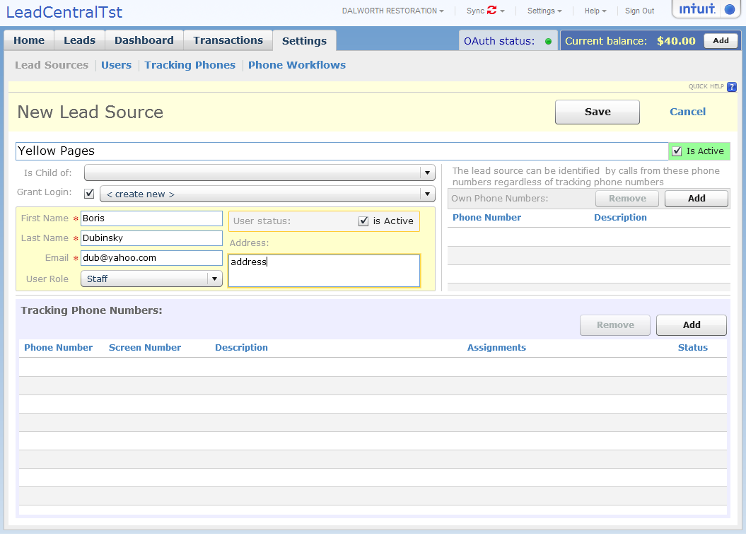

Phone calls matched to lead sources in two ways:
- Lead source provides her own phone number and can call on any lead central phone number
- Lead source gets assigned tracking number

Optionally assign phone number owned by lead source.

On this screen show write well formatted phone number like (214) 134 1234
Put description “James’s cell”
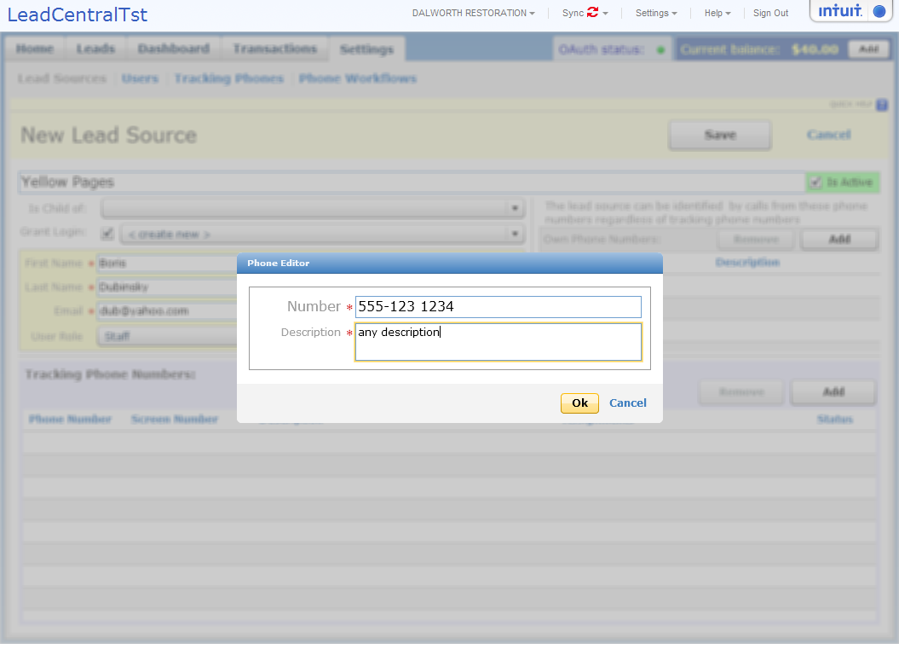

Again put “Brenda’s Maid Services”
Brenda Smith
brenda.smith@yahoo.com

Adding tracking phone number

Add tracking phone number. Lead source can have many tracking phone numbers.

Click Add (arrow to the button like on 37 signals)

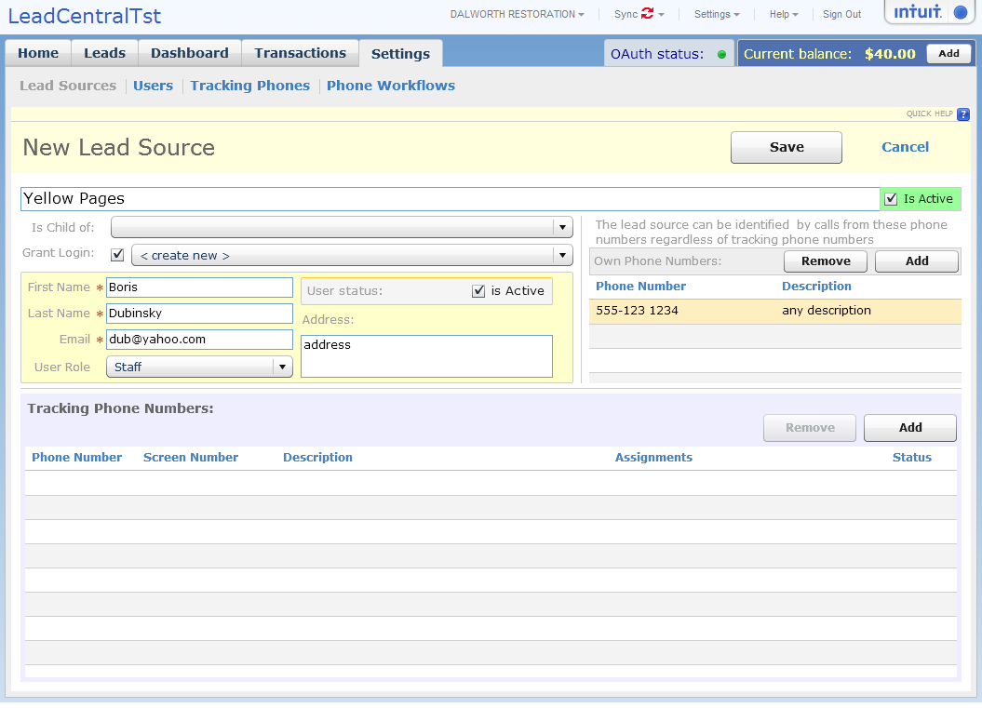

- Select unassigned phone number or Purchase New

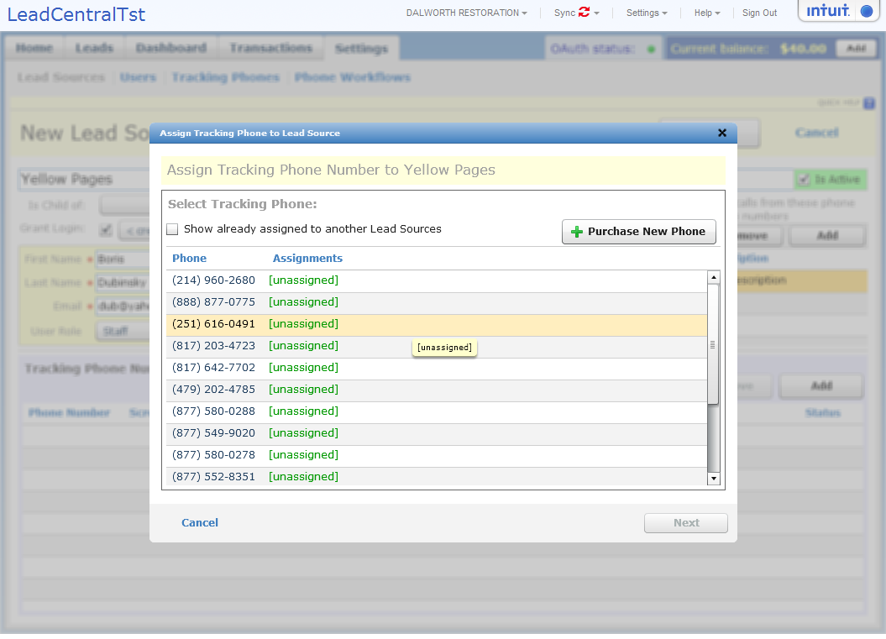

- Purchase new Tracking Phone:
Select Toll Free or Local phone number
Select Area and prefix

Purchase Phone Number
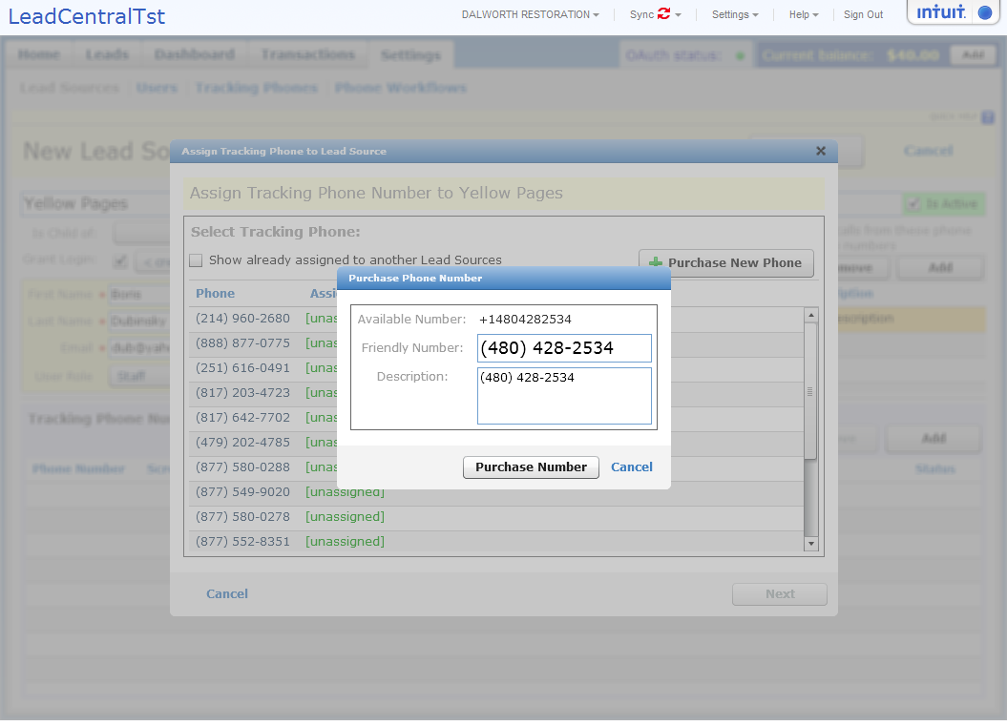

3 Confirm Assigning phone number to Lead Source
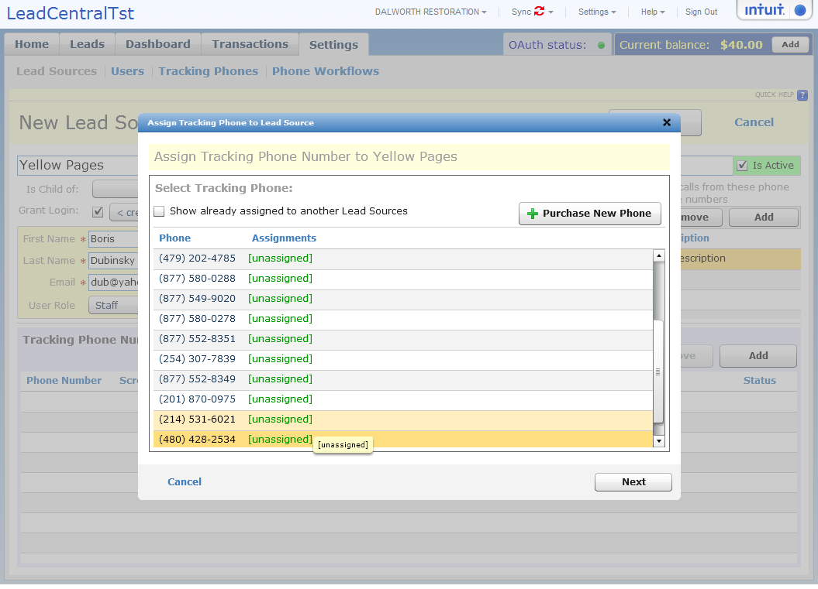

- Add phone rules (if empty – will work voice mail flow).
Q: What are phone rules?
A: Phone rules allow you to specify what Lead will do with the call depending on the time of day. Lead central can forward call to the phone specified in workflows or save it as a voice mail.
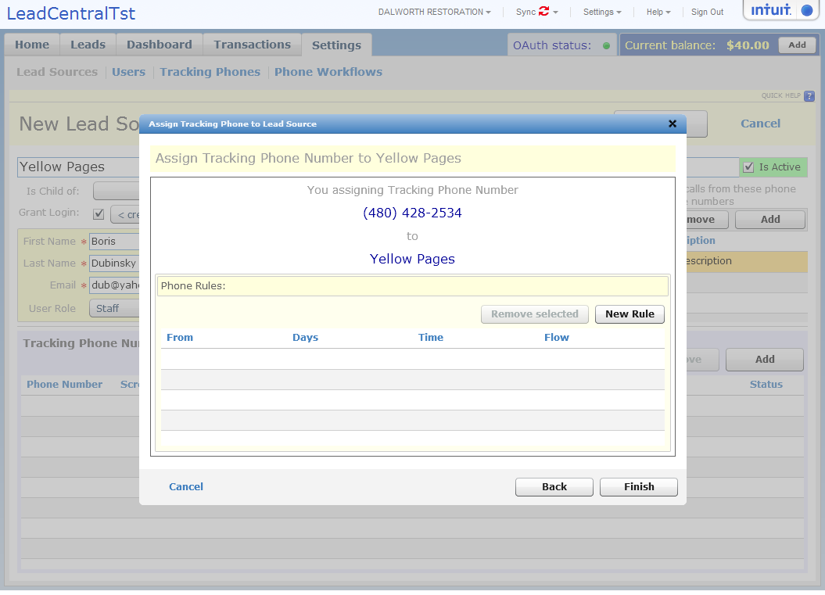

Create new Rule “Redirect call” for Monday-Friday and 8:00AM to 6:00PM
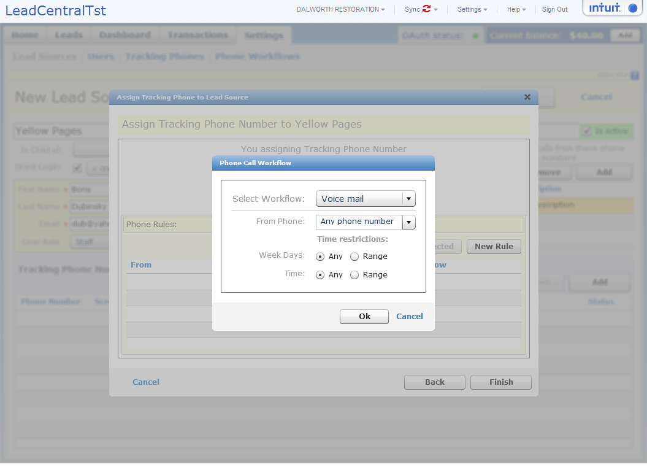

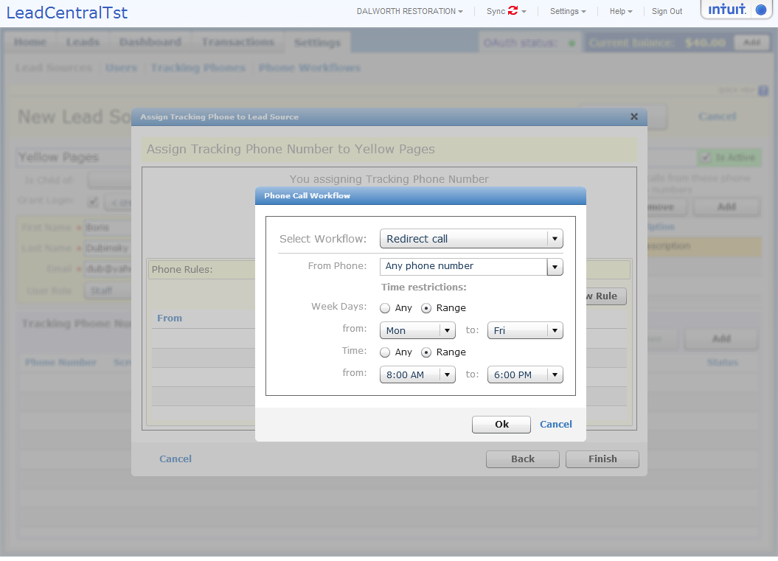
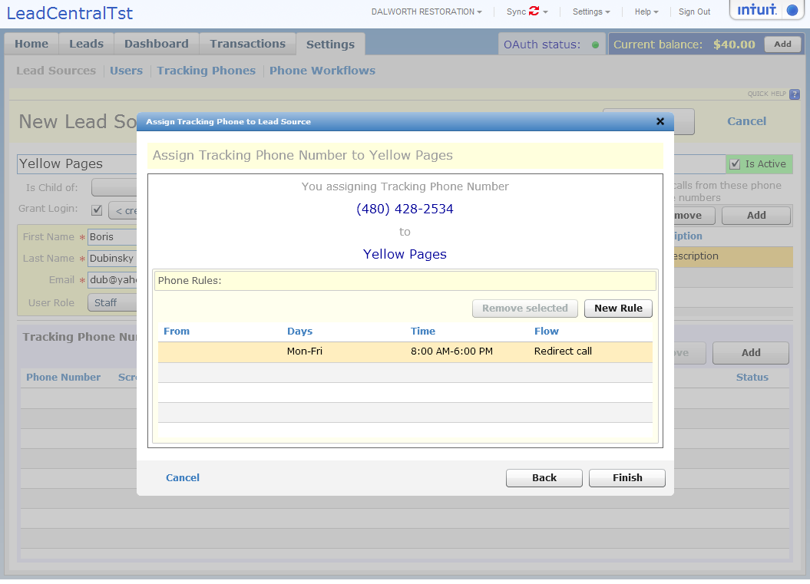

Add extra rules:
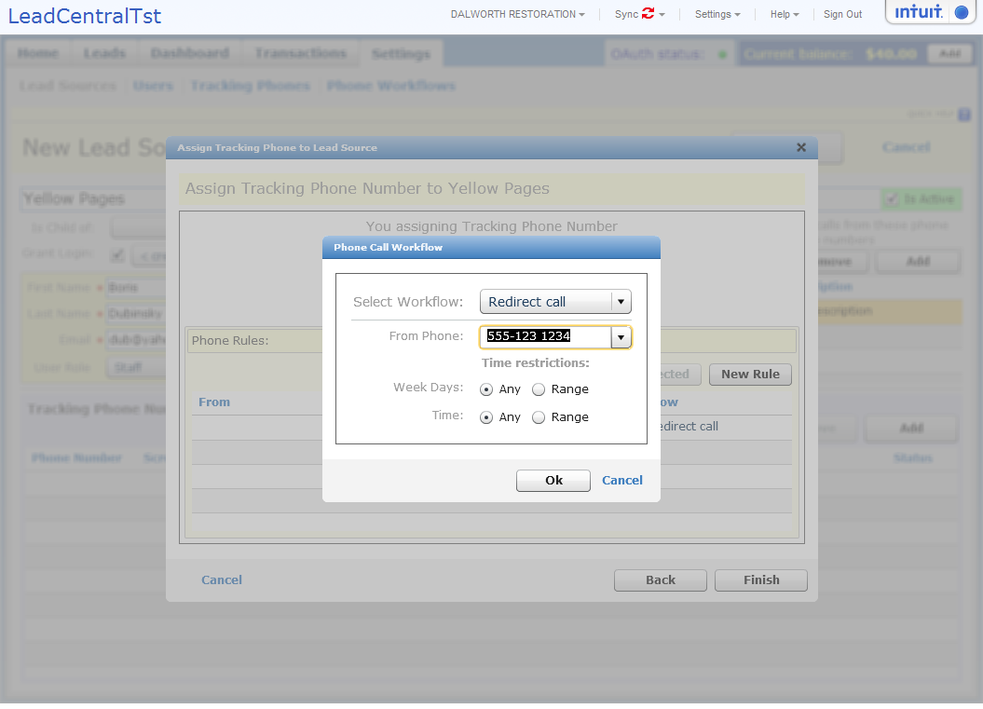
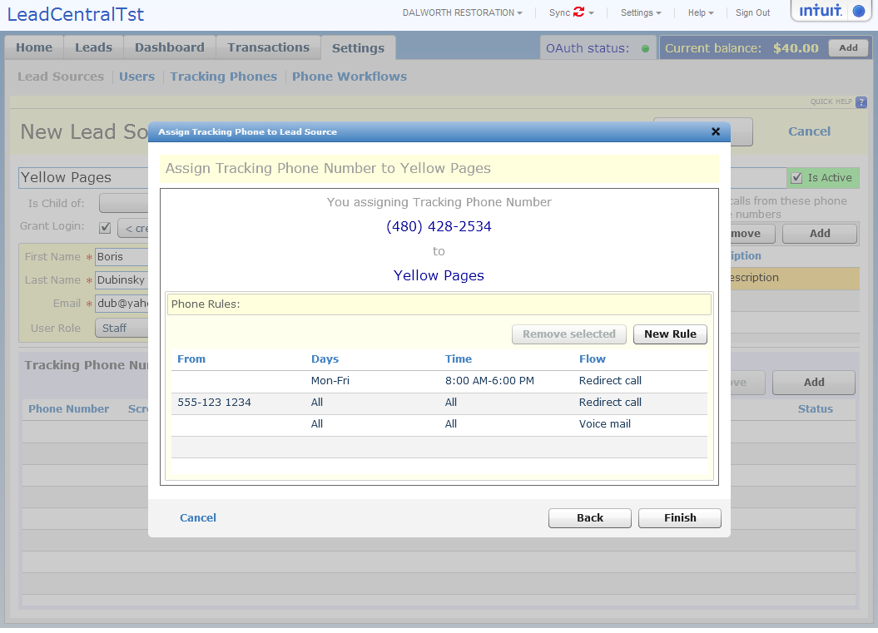

Review and Save Lead Source:
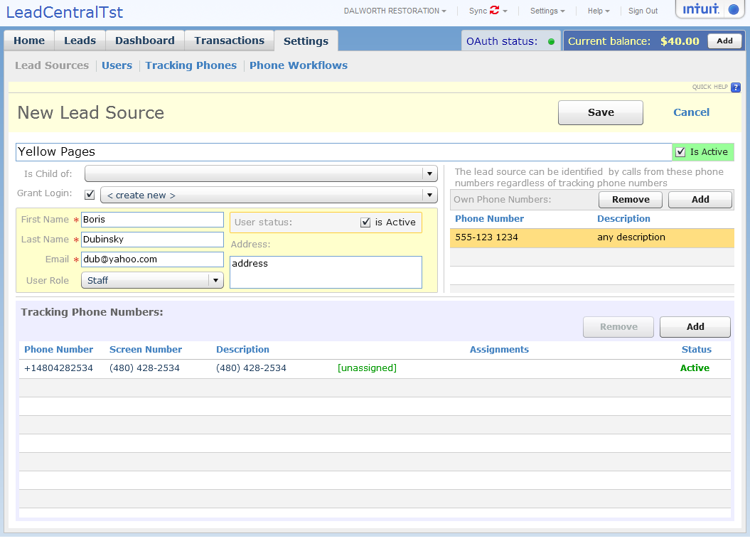
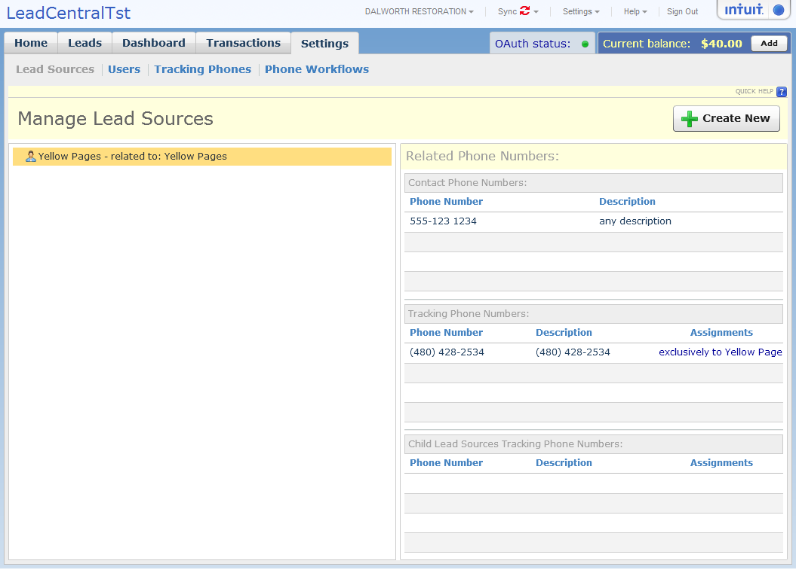

Update Lead Sources

Application User management:
www.theleadcentral.com/help/users/admin/settings/user-management

You tube video
Administrator can create users – Administrators, Stuff and Business Partners.
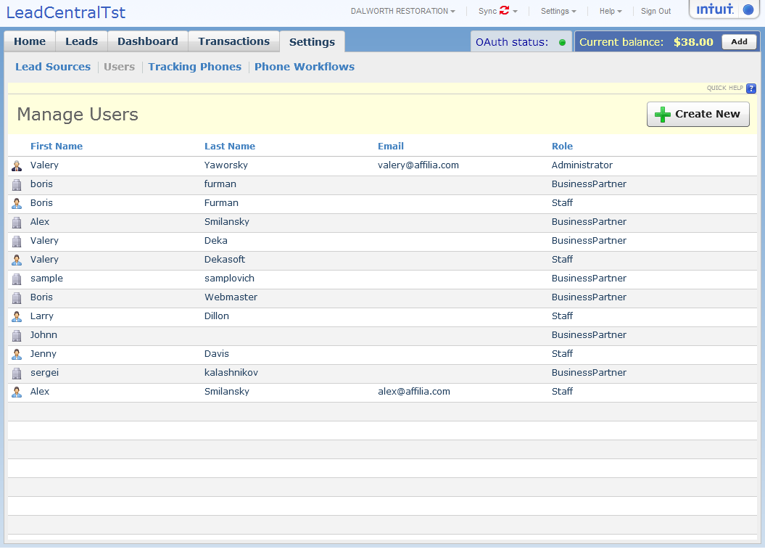
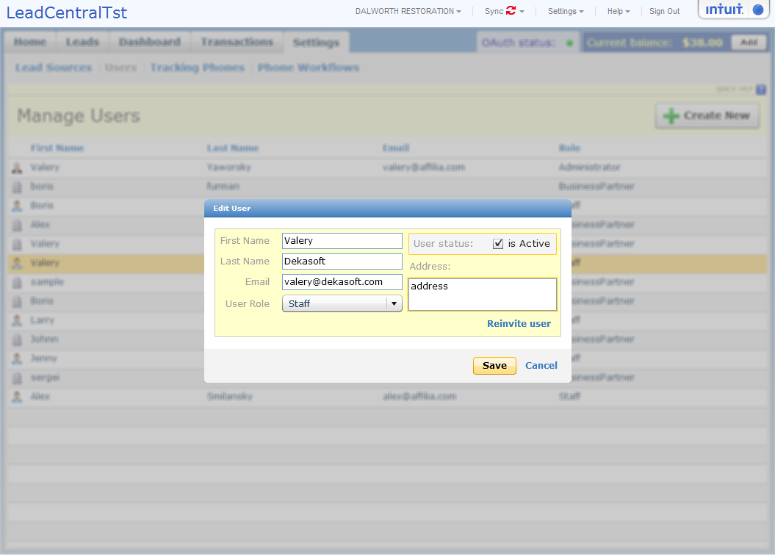

Tracking Phones Management:
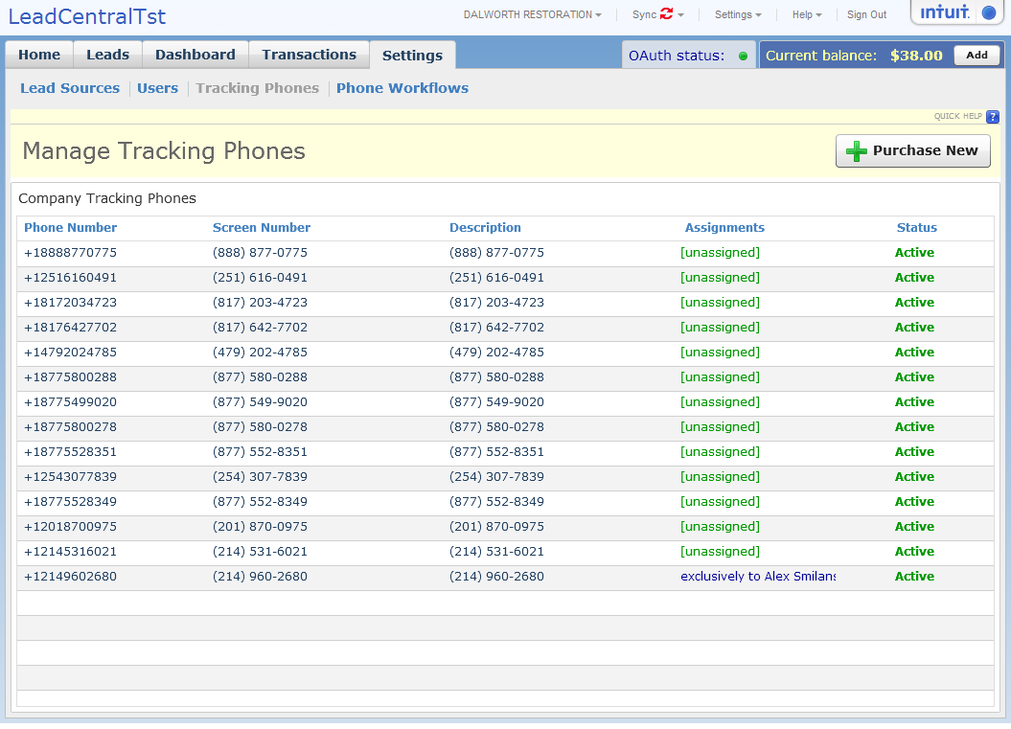
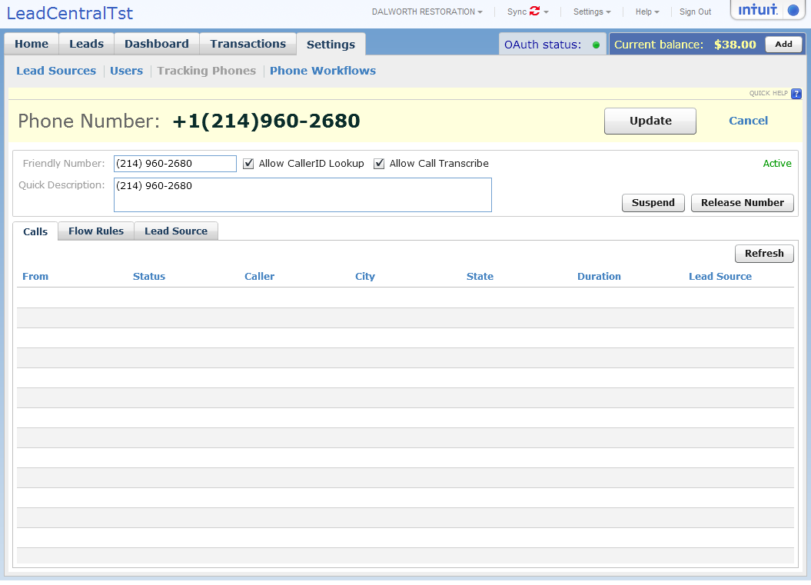
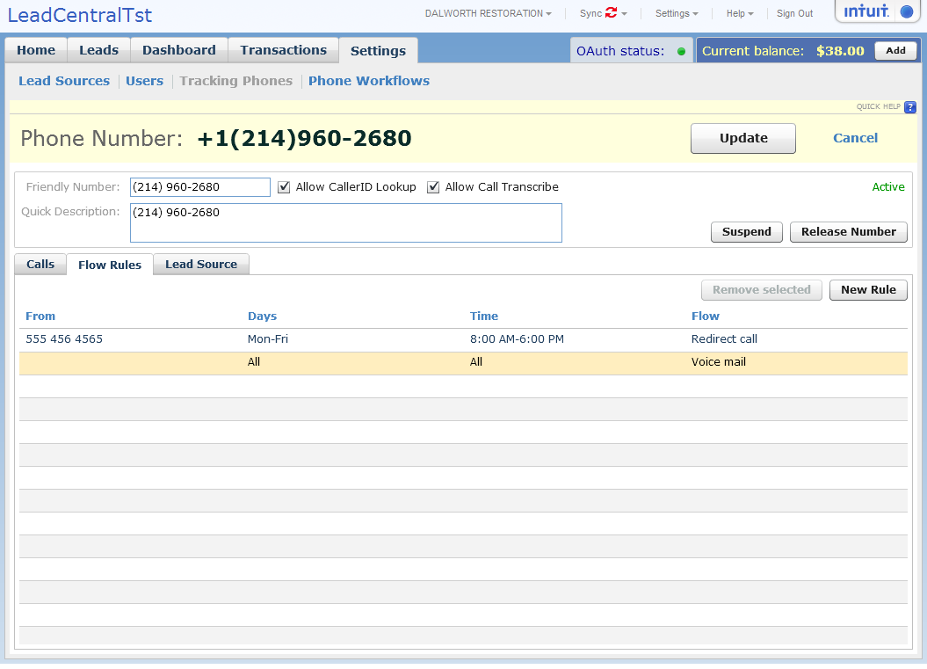
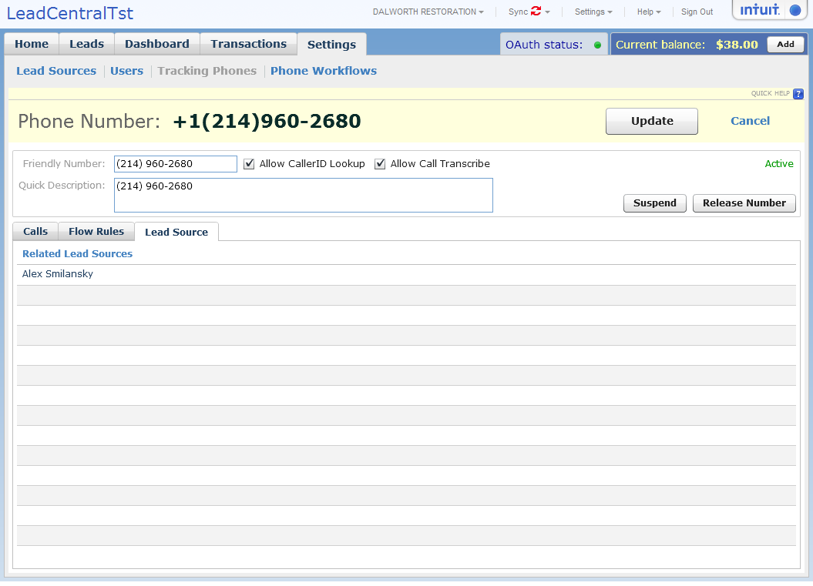

Manage Tracking phones
www.theleadcentral.com/help/users/admin/settings/trackingphones

YouTube Video
Text

Manage Phone WorkFlows
www.theleadcentral/help/users/admin/settings/workflows

Youtube video
Text

Business Partner Functionality (www.theleadCentral.com/help/partners)

Home Page

Manage Leads

Dashboard

Staff Functionality (www.theleadcentral.com/help/staff)

Home Page

Manage Leads

Dashboard

Settings

